CURRICULAM VITAE

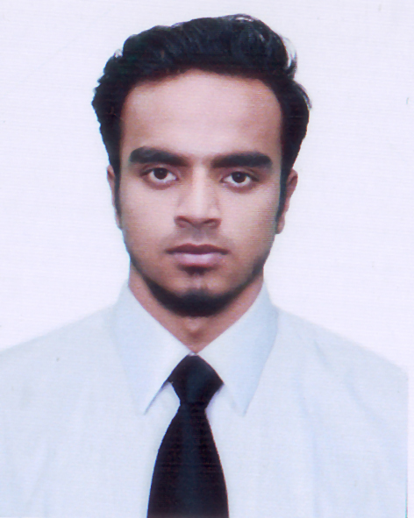
MD.AZHARUL ISLAM
Mailing Address: Kayempur, Shibu Market,
Fatullah, Narayangaj.
Contact: +8801910-701653
E-mail: azhashiq786@gmail.com

CAREER Objective

Looking for a career where there is an equal opportunity of growth & development with challenging environment that I can show strong sense of responsibility, dignity of work and devotion for building a bright career and developing the organization.

Educational Qualification

Paramedical

Institute : SAICT Institute.
Location : Dhaka, Bangladesh.
Subject : Medicine & Health
Passing Year : Running

Higher Secondary Certificate Examination (H.S.C)

Institute : Narayanganj College & University.
Location : Narayanganj.
Group : Business Studies
Result : 3.25
Passing Year : 2017
Board : Dhaka.
Secondary School Certificate Examination (S.S.C)

Institute : Harbard Academy.
Location : Narayanganj.
Group : Business Studies
Result : 3.56
Passing Year : 2014
Board : Dhaka.
Computer Skill

Computer Office Management: MS Word, MS Excel, MS Access, Internet Browsing, Adobe Photoshop, Photographing Etc.

Language Proficiency

Bengali: Extensive communicative skill as native one.
English: Good in listening, reading, speaking and writing.

Hobbies And Interests

- Have great interest in Cricket and played a lot in School and College.
- Worldwide Photography.
- Travelling new place.
Job Experience:

Company Name : Oppo Mobile
Designation : Oppo Sales Representative.
Duration : 2016 - 2017 (1 Year’s).

Company Name : Lava International Bangladesh.
Designation : Brand Promotion Officer
Duration : 2017 - 2019 (2 Year’s).

Company Name : Tecno Mobile Bangladesh.
Designation : Tecno Brand Promoter
Duration : 2019 – Running..
Personal Information

- Father’s Name : Md. Shafiqul Islam
- Mother’s Name : Moyna Begum
- Date of Birth : 8th February, 1998
- Sex : Male
- Height : 5′6″
- Weight : 58 Kg
- Marital Status : Unmarried
- Blood Group : O (+ve)
- Religion : Islam
- Nationality : Bangladeshi by birth.
- Permanent Address : Shibu Market, Fatullah, Narayanganj.

Reference

01. Name | : | Md. Fahim Ahmed  T.S.M.  Huawei Mobile  Narayanganj.  Cell: +8801672-727181
02. Name | : | Md. Sohanur Rahman  H.B.C.  Huawei Mobile  Narayanganj.  Cell: +8801534-324696

--------------------
Md. Azharul Islam
Date:...................

